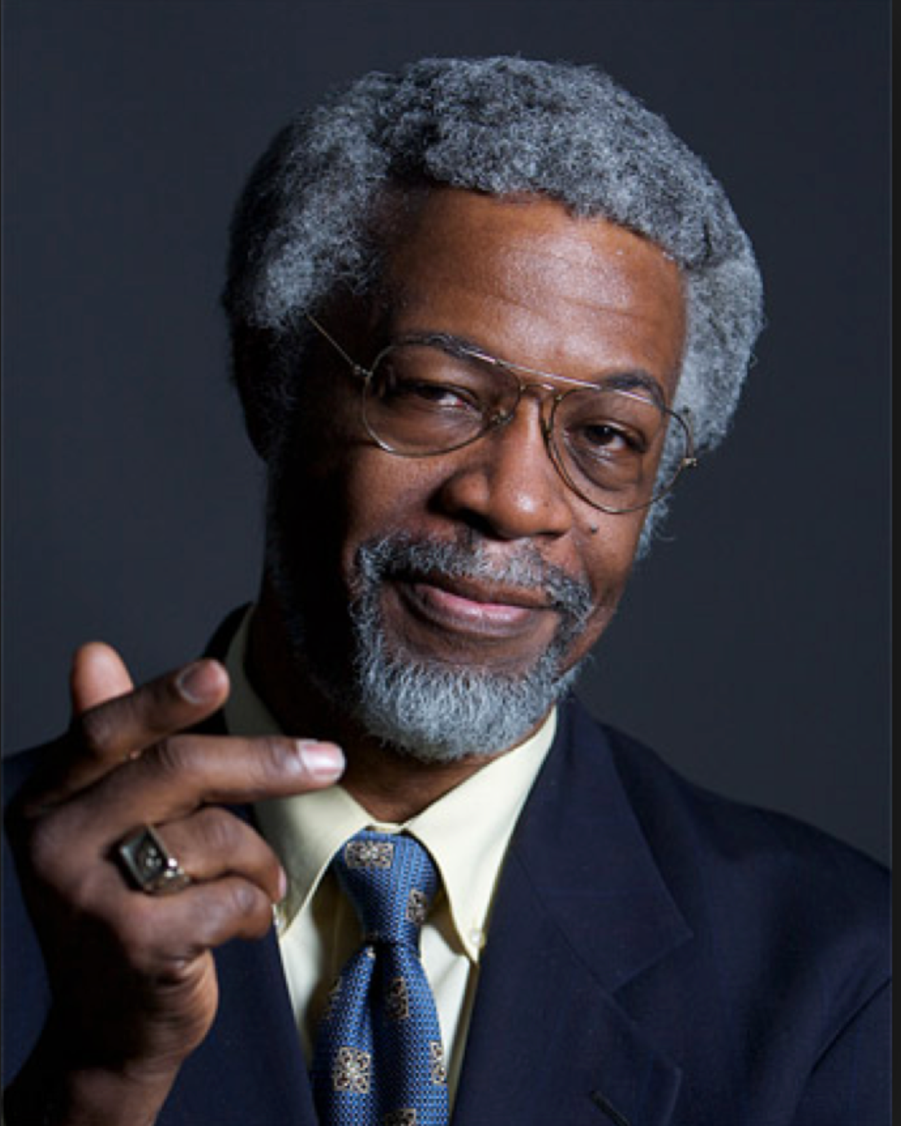

Renowned theoretical physicist and US Presidential advisor on Science & Technology Professor Sylvester James Gates will give a lecture on Monday 7 December, 15:00 – 16:00

“United States Climate Change Policy: President Obama's Council of Advisors on Science and Technology Reports on Climate and Environment”

Location: L9 ground floor lecture theater, Hawkesbury Institute for Environment, WSU Hawkesbury Campus.
This presentation will review the policy recommendations that flow from two reports by the U.S. President's Council on Science and Technology (PCAST) on the topic of climate and environment. After the presentation, you are invited to engage in an informal conversation with Prof. Jim Gates over light refreshments at 16:00 – 17:00.
The US PCAST is a council of US Nation’s leading scientists and engineers, appointed by the President with a broad mandate to provide advice to him on science and technology from inside the White House and from cabinet departments and other federal agencies. There are currently 18 council members. Prof. Gates will discuss some of the recommendations made to the President as the Administration prepares new initiatives to tackle the challenges posed by Earth’s changing climate.
Sylvester “Jim” Gates is Professor of Physics, University System of Maryland Regents Professor and Director of the Center for String and Particle Theory at the University of Maryland. He was recently awarded the National Medal of Science, the US nation’s highest award in science. In 2014, he was honored as the Harvard University 2014 Scientist of the Year. He was also the Mendel Medal winner in recognition of his influential work in supersymmetry, supergravity and string theory, as well as his advocacy for science and science education in US and abroad. He works with the National Commission of Forensic Science to improve the quality of forensic science and holds membership in a number of organizations, including the American Association for the Advancement of Science and is a member of the Maryland State Board of Education. In 2013 he was the first African American physicist elected to the National Academy of Science. He has served as a consultant to the National Science Foundation, the US Departments of Energy and Defense, and held appointments at MIT, Harvard, California Institute of Technology and Howard University. Prof Gates has avidly and widely promoted science and science education through many different forums and media, including as a frequent guest on The Public Broadcast System's NOVA productions, in popular videos about the science of NFL football and NHL hockey, and as a featured presenter at the World Science Festivals. He is prominent in promoting the roles that educators can play in advancing national priorities related to science and math literacy as well as college graduation rates.

